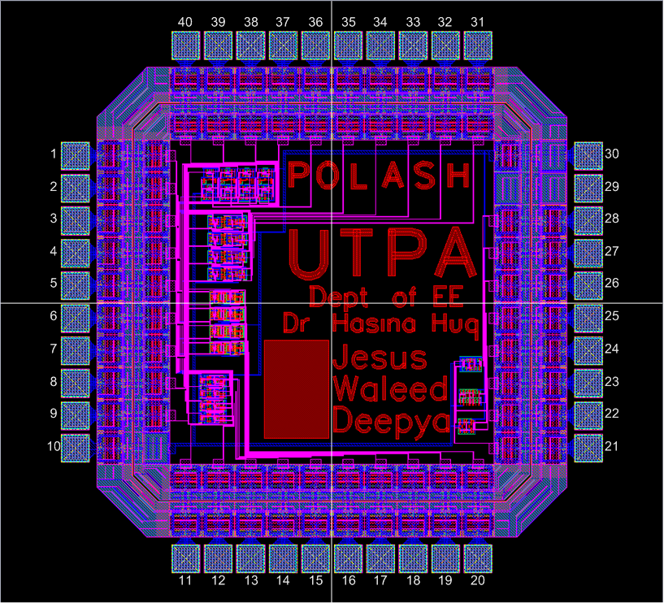
Pad Frame
Pad Frame
Pin Out

Four 4-bit adders:
Common Inputs and Individual Outputs
(aislin10, straterg, amiller, bigbot are the account user names of designed the

Three D-flip flops
Common Inputs and Individual Outputs – three different filp-flops
(J – Jesus, W – Waleed, D – Deepya)
Schematic Diagram:

Figure: The layout of the prototype Micro-Chip (Layout from Cadence)
Integrated Circuit (IC) Design using CMOS technology; AMI 0.5 process

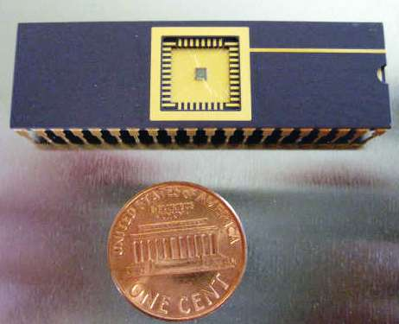

Fabricated IC by UTPA-EE students using MOSIS facilities (Packaged in DIP 40)

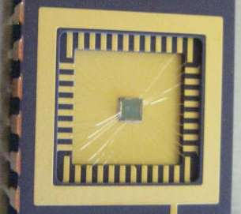
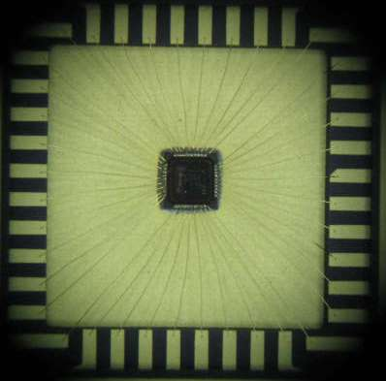
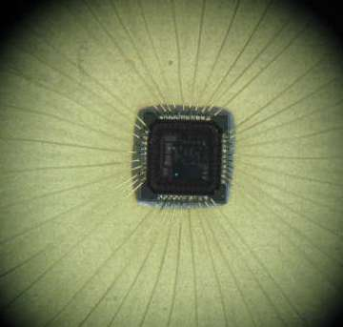

a) Pad frame b) Wire Bonding c) Designed IC on Si Wafer
Microscopic Image: Microscopic Image: Cavity Size 7874um X 7874um Die Size 1615umX1644 um

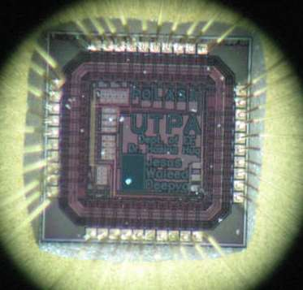
Designed IC on Si Wafer (Microscopic Image: Die Size 1615 um X 1644 um)
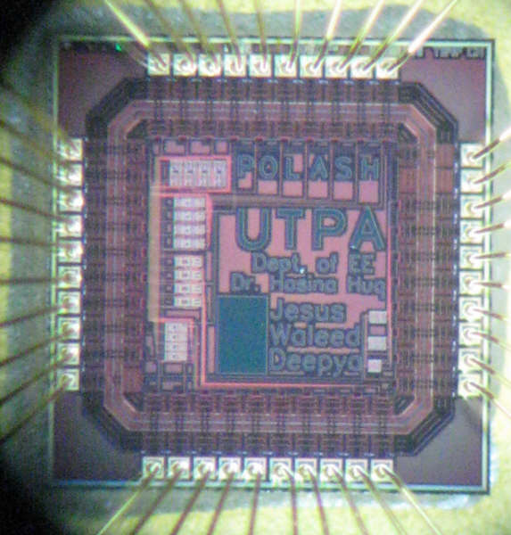
Pin out
Pad Frame

The prototype integrated circuit is developed using 0.5 micron standard CMOS process available through MOSIS.

Designed circuitry
Designed circuitry

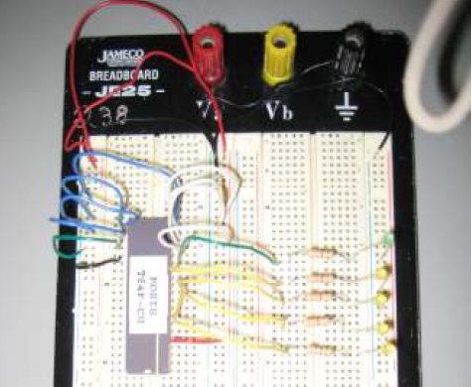
Test board for the chip

